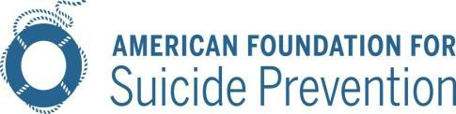

AFSP Model Legislation: Suicide Prevention in Schools

- Beginning in the 2016-2017 school year, the State Board/Department of Education shall adopt rules to require that all public school personnel receive at least 2 hours of suicide awareness and prevention training each year*. This training shall be provided within the framework of existing in- service training programs offered by the State Board/Department of Education or as part of required professional development activities.

- The State Board/Department of Education shall, in consultation with state agency/coalition charged with coordinating state suicide prevention activities, other stakeholders, and suicide prevention experts, develop a list of approved training materials to fulfill the requirements of this Section.
  - Approved materials shall include training on how to identify appropriate mental health services both within the school and also within the larger community, and when and how to refer youth and their families to those services.
  - Approved materials may include programs that can be completed through self-review of suitable suicide prevention materials.

(3)
- Each public school district shall adopt a policy on student suicide prevention. Such policies shall be developed in consultation with school and community stakeholders, school employed mental health professionals, and suicide prevention experts, and shall, at a minimum, address procedures relating to suicide prevention, intervention, and postvention.
- To assist school districts in developing policies for student suicide prevention, the Department of Education shall develop and maintain a model policy to serve as a guide for school districts in accordance with this section.

(4)
- No person shall have a cause of action for any loss or damage caused by any act or omission resulting from the implementation of the provisions of this Section or resulting from any training, or lack thereof, required by this Section.
- The training, or lack thereof, required by the provisions of this Section shall not be construed to impose any specific duty of care.

*In those states where the legislature must amend section (1) to require training less often, for example, once every 5 years, or that remove a frequency requirement entirely, a new section will be added that states:
The State Board/Department of Education shall adopt rules to require that all newly employed public school personnel receive at least 2 hours of suicide awareness and prevention training within 12 months of their date of hire.

AFSP Public Policy Office • 440 First Street, NW, Suite 300 • Washington, DC 20001 Phone: 202-449-3600 • Fax: 202-449-3601 • www.afsp.org

