State Laws: Suicide Prevention Training for School Personnel

...
6H.I.,..
•
II Requires annual training Requires non-annual training
IIEncourages training
II
IINo training law

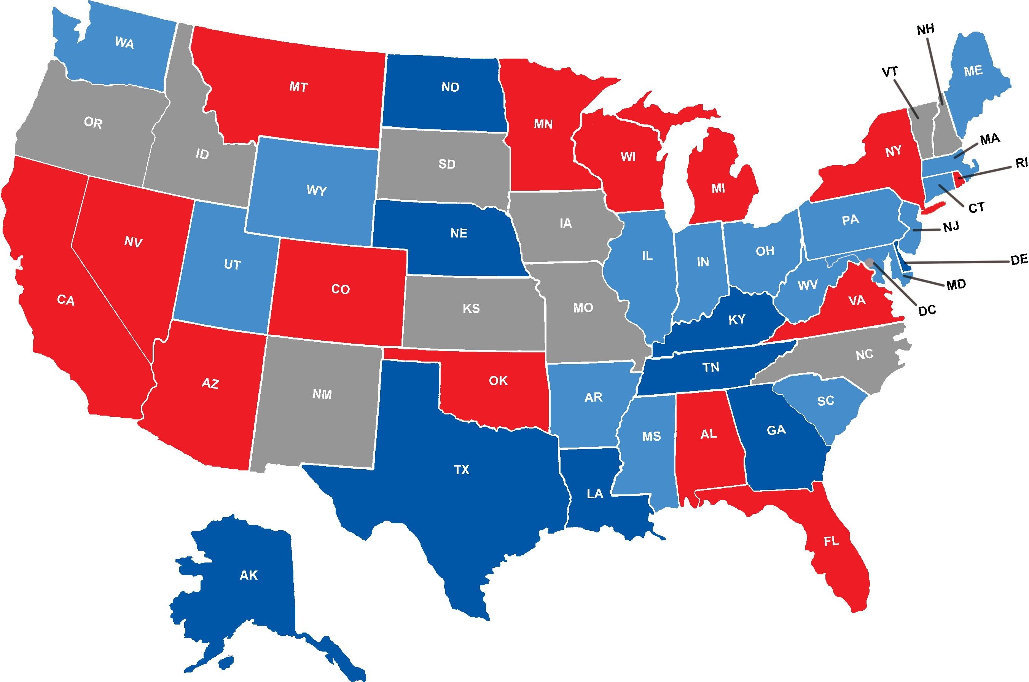
July 2015

